**Social Interaction Tracking and Patient Prediction System for Potential COVID-19 Patients**

* a B LE (Bluetooth L ow Energy) and GPS based social interaction tracking system.
* developed an algorithm to predict the possibility of being infected with COVID-19 based on the collected data
* we performed a simulation of the system with a graph-based model to analyse the behaviour of the proposed algorithm and it verifies that self-isolation is important in slowing down the disease progression
* there are 3 major entities i.e., (i) users with smartphones, (ii) cloud

servers and (iii) authorities and medical officers.

* To connect with the system, each user has to install a specific app in

their smartphones and register with the system.

* Under the operation of the system, each smartphone broadcasts BLE

advertisements as indications of its presence. In this case, the

broadcasting advertisement will only consist of a random ID,

which is assigned to the mobile phone via the cloud server

during the registration.

* Especially this ID would change after a certain period to avoid unnecessary tracking of mobiles.
* The registered mobile phones continuously listen and make records

of the advertisements receiving from the nearby mobiles.

* Here, the mobile app records two specific parameters, namely (i)

RSSI value of the received BLE advertisements and (ii) contact

period with each mobile.

* In addition to that, with the user permission, the mobile application keeps track of the GPS locations of the mobile relay periodically, according to user

preferences.

* After gathering these data and calculating risk levels, the mobile will transmit the data into the cloud server via an active connection to perform second stage refined predictions and associated contact tracing.
* In this case, the data transmission work is performed as a real-time or periodic procedure according to the user preferences and the availability of the internet connection.
* Then, if one of the users get infected from COVID-19, the responsible authorities get access to server data and analyze to get more detailed outputs.
* In this case, specific algorithms aid with the server operation to extract

out more accurate results.

* In addition to that, the servers can calculate the risk levels associated with each contact of the patient and predict their probability of infection. At the end of the procedure, the system notifies all the contacts according to their associate risk level and guide them to take further actions to avoid further

spread of disease.

* Especially, the medical officers like doctors and public health inspectors who are working in regional areas related to the patient and his/her contacts can get notified to take immediate actions to neutralize the newly identified

cluster.

* In addition to that, the authorities can get a map view of the traces of the patient if the GPS tracking feature is enabled by the user.
* RSSI (Received Signal Strength Indicator) RSSI depends on distance and broadcasting power. To estimate the distance, a simplified form of the relation between distance and RSSI is widely used feature of ble
* 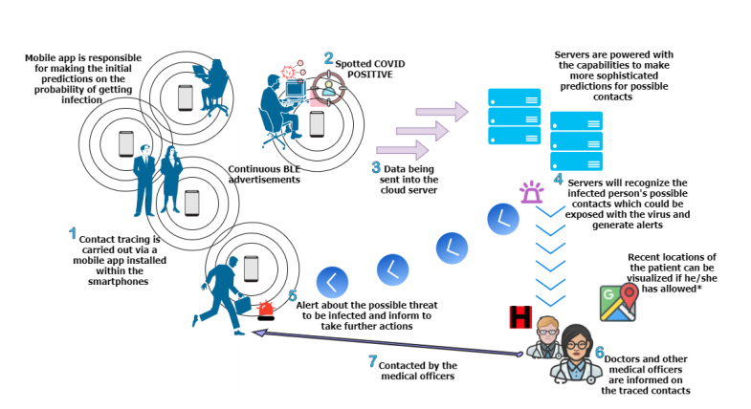Own prediction algo using rssi, developed only for Andriod users**A study on**

**COVID-19 app’s satisfaction & user attitude in digital combat of coronavirus pandemic**

* This study only involves the user satisfaction aspects and not the short comings of the Application itself
* The app uses the phone’s Bluetooth and GPS capabilities. It will keep a record of all other Aarogya Setu users that it detected nearby using Bluetooth. It will also use a GPS log of all the places that the device had been at 15-minute intervals.
* These records are stored on the phone till the time any user tests positive or declares symptoms of COVID-19 in a self-assessment survey in the app. In such cases, the records are uploaded to the servers.
* Aarogya Setu has following:

1. User Status (tells the risk of getting COVID-19 for the user)
2. Self Assess (helps the users identify COVID-19 symptoms and their risk profile)
3. COVID-19 Updates (gives updates on local and national COVID-19 cases)
4. E-pass integration (if applied for E-pass, it will be available)[9]
5. See Recent Contacts option (allows the users to assess the risk level of their Bluetooth contacts)[10]
6. It tells how many COVID-19 positive cases are likely in a radius of 500 m, 1 km, 2 km, 5 km and 10 km from the user.[11]
7. The app is built on a platform that can provide an application programming interface (API) so that other computer programs, mobile applications, and web services can make use of the features and data available in Aarogya Setu.

**An Automated Contact Tracing Approach for Controlling Covid-19 Spread Based on Geolocation Data from Mobile Cellular Networks**

* The proposed framework facilitates contact tracing without necessitating smartphones. Since in many countries especially in developing countries smartphone penetration rate is significantly low, BLE based technology may not be very effective in those countries. In the geolocation-based approach proposed in this article, any type of mobile phone with an active SIM card will work and thus the proposed approach can be equally effective in developing countries as well as in countries where smartphone penetration rate is significantly higher.
* In the proposed model, no Bluetooth/ Wi-Fi/ NFC enabled cell phone is needed as the operator will use the geolocation-based tracing approach by getting the location data directly from the base station to identify the likely infected persons
* Involves an additional questionnaire for self-analysis (Like Arogya setu)

**OUR RESEARCH PROPOSAL.**

* No need for registration, automatic fetching of the information once the application is downloaded
* Machine learning algorithm to automatically alert the authorities if cases in an area are increasing
* A way of tracking a person if they tested positive in order to make sure they are following the guidelines properly
* A similar system for people who have come in contact with an infected person in order to ensure they are in quarantine
* According to the guidelines issued by the government, the application must be able to alert the authorities if the user is found to be not be following them (eg an automatic trigger, that alerts authorities if there are more than 10 people gathered in an area and are in close proximity with each other eg 2m.)